|  |  |
| --- | --- |
| **DOKUMENTASI EKSTERNAL**  External Documentation |  |
| **[TUGAS PROYEK]**  **[*Project*]** |
| **MATAKULIAH <COMP6176> – <Human And Computer Interaction – PW01>**  ***Subject*** |
| SEMESTER [GENAP] 2020/2021 ***[Even] Semester Year 2020/2021*** |

## Judul Proyek

*[Assignment / Project]**Title*

* **Store Del Luna**

## Pendahuluan

*Introduction*

* **Store Del Luna is a famous merchandise and albums shop for K-Popers established in June 2013. We provide original K-Pop albums and merchandises from many artists. Store Del Luna plans to dive into the world of digital business but Store Del Luna needs to create a logo and company website that represents Store Del Luna’s. So here we gonna create a company website for Store Del Luna to improve their service towards their customers.**

## Dokumentasi

*Report / Documentation*

* **REPORT / PRINT SCREEN & DESCRIPTION**
  + **DETAIL 1 Header homepage**

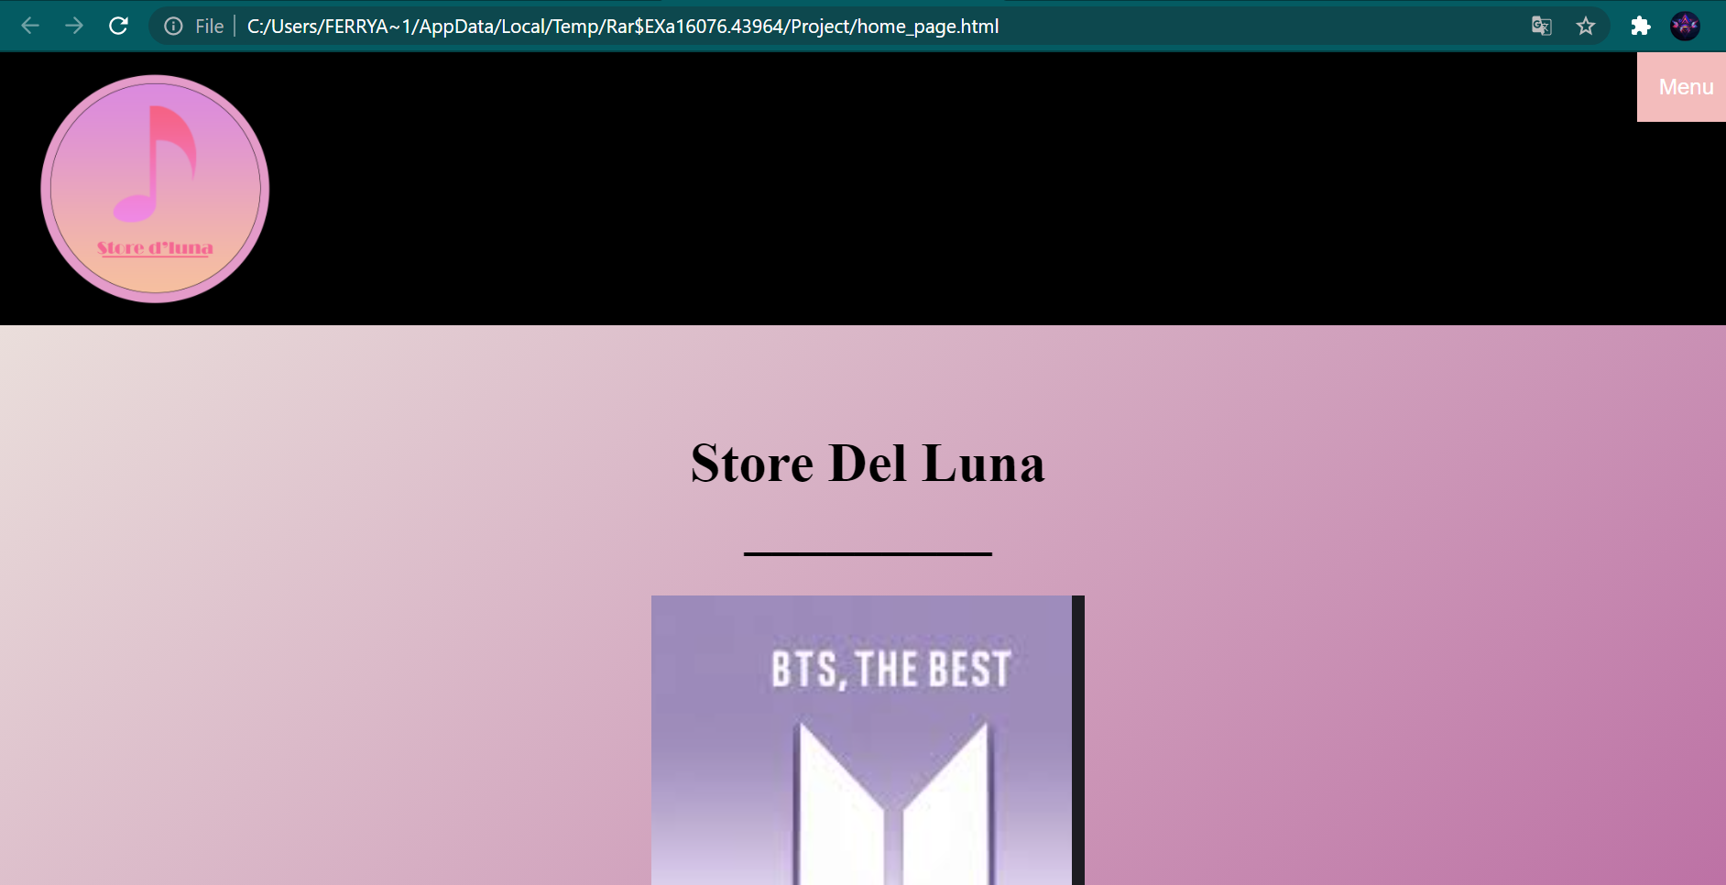

* + **DETAIL 2 pada bagian menu**

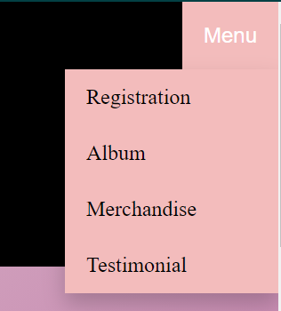

* + **DETAIL 3 merchandise**

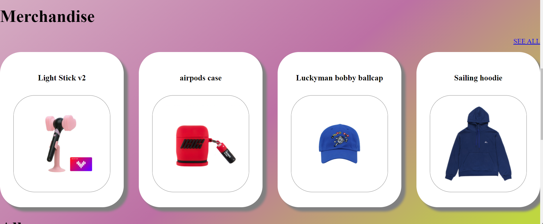

**Setelah di klik SEE ALL pada bagian merchandise**

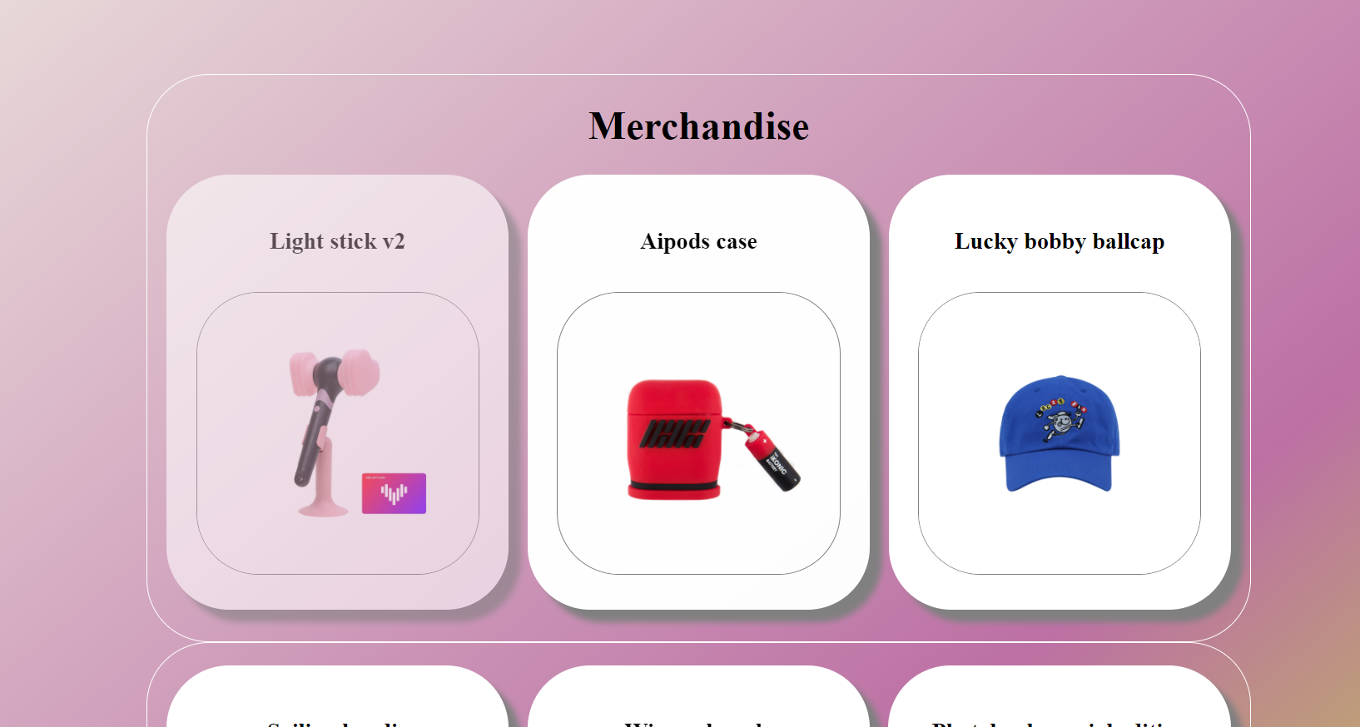

* + **DETAIL 4 album**

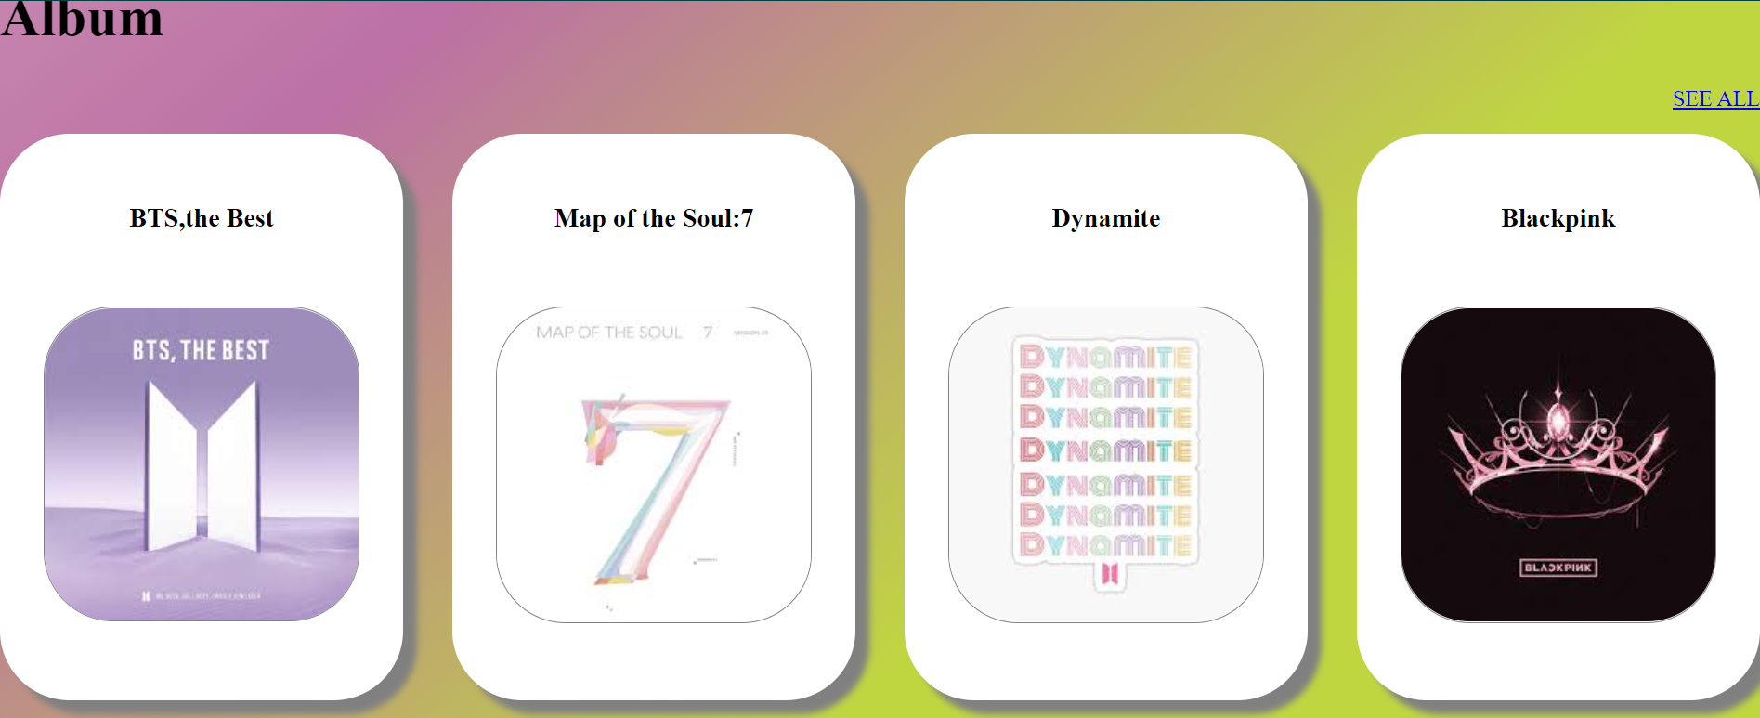

**Setelah di klik SEE ALL pada bagian album**

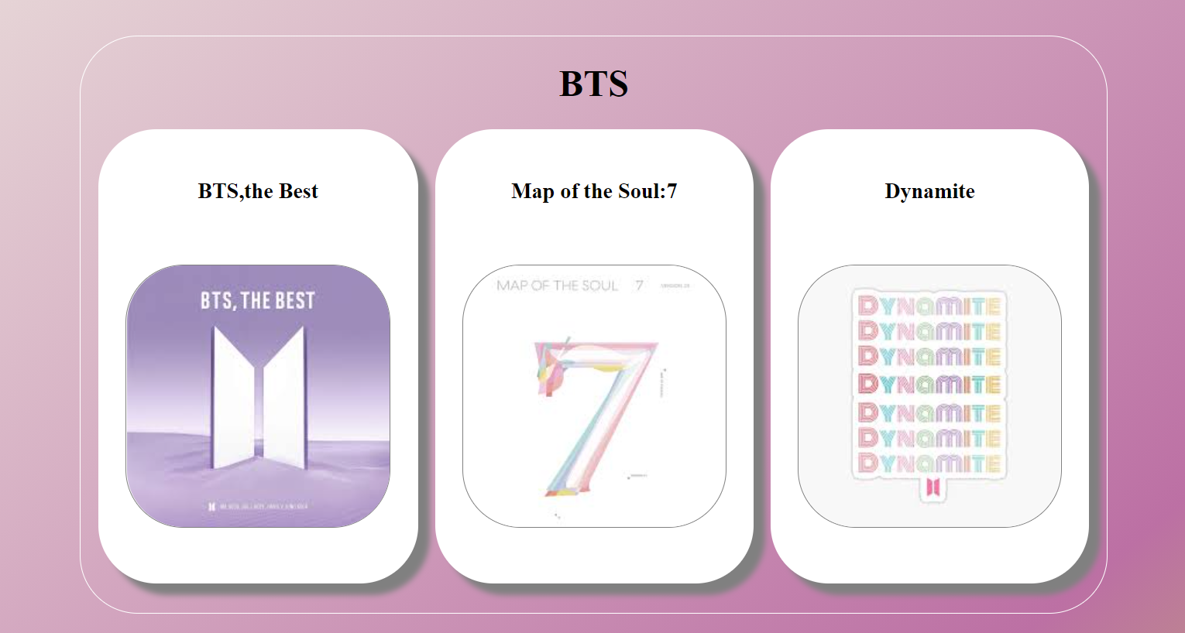

* + **DETAIL 5 footer**



## Referensi

*References*

* **LINK and REFERENCES**

**link gambar merchandise**

**- https://m.en.ygselect.com/product/blackpink-official-light-stick-ver2-limited-edition/5815/category/43/display/1/#none**

**- https://m.en.ygselect.com/product/ikon-airpods-silicone-case-set/5359/category/42/display/1/**

**- https://m.en.ygselect.com/product/luckyman-bobby-ballcap/5996/category/1/display/77/**

**- https://m.en.ygselect.com/product/sailing-akmu-hoodie/5177/category/45/display/1/**

**- https://m.en.ygselect.com/product/remember-winner-bangle/5331/category/31/display/1/**

**- https://m.en.ygselect.com/product/jennie-solo-photobook-special-edition/4744/category/538/display/1/**

**- https://m.en.ygselect.com/product/r-ros%C3%89-mug/6107/category/1/display/4/**

**- https://m.en.ygselect.com/product/iloveyou-treasure-card-phonecase/5686/category/57/display/1/**

**- https://m.en.ygselect.com/product/theshow-blackpink-ecobag/5867/category/645/display/1/**

**link gambar sosmed**

**-https://pngtree.com/so/facebook**

**-https://pngtree.com/so/instagram**

**link gambar testimonial**

**-https://www.freepik.com/free-vector/customer-satisfaction-design_3187688.htm#page=1&query=testimony&position=3**

**-https://stock.adobe.com/id/images/id/238843989?as_campaign=Freepik&as_content=api&as_audience=404&tduid=a53faaaa7186410f08f99cda99a509d5&as_channel=affiliate&as_campclass=redirect&as_source=arvato**

**-https://www.google.com/search?q=jerinx&tbm=isch&ved=2ahUKEwib4Y6itajxAhVmCLcAHZjDCfsQ2-cCegQIABAA&oq=jerinx&gs_lcp=CgNpbWcQAzIICAAQsQMQgwEyBQgAELEDMgIIADICCAAyAggAMgIIADICCAAyAggAMgIIADICCAA6BAgAEEM6BwgAELEDEENQ04DhFlj4heEWYKyI4RZoAHAAeACAAYUBiAG4A5IBAzUuMZgBAKABAaoBC2d3cy13aXotaW1nwAEB&sclient=img&ei=SlzQYJuULuaQ3LUPmIen2A8&bih=722&biw=1536&safe=strict#imgrc=bXBZeJoEK1yEUM**

**-https://www.google.com/search?q=raisa&tbm=isch&ved=2ahUKEwiogciJ56nxAhXKMLcAHeYOCEsQ2-cCegQIABAA&oq=raisa&gs_lcp=CgNpbWcQAzIFCAAQsQMyCAgAELEDEIMBMggIABCxAxCDATICCAAyAggAMgIIADICCAAyAggAMgIIADICCAA6BAgAEANQ3vgDWIv9A2Dl_gNoAHAAeACAATiIAfYBkgEBNZgBAKABAaoBC2d3cy13aXotaW1nwAEB&sclient=img&ei=vBbRYKizL8rh3LUP5p2g2AQ&bih=722&biw=1536&safe=strict#imgrc=SusY-8O8kCMAjM**

**-https://www.google.com/search?q=deddy+corbuzier&tbm=isch&ved=2ahUKEwiInrCp56nxAhXlXnwKHeZ4DlkQ2-cCegQIABAA&oq=deddy+&gs_lcp=CgNpbWcQARgAMgUIABCxAzIFCAAQsQMyBQgAELEDMgIIADICCAAyAggAMgIIADICCAAyAggAMgIIADoECAAQQzoICAAQsQMQgwE6BwgAELEDEEM6BAgAEANQ5JEBWJyZAWDYpAFoAHAAeACAAT-IAcYCkgEBNpgBAKABAaoBC2d3cy13aXotaW1nwAEB&sclient=img&ei=_xbRYMiiHuW98QPm8bnIBQ&bih=722&biw=1536&safe=strict#imgrc=FyRBrNh_BpiJbM**

**-https://www.google.com/search?q=picky+picks&tbm=isch&ved=2ahUKEwiDof6z56nxAhXzD7cAHXSEBfEQ2-cCegQIABAA&oq=picky+picks&gs_lcp=CgNpbWcQAzICCAAyAggAMgIIADICCAAyAggAOgUIABCxAzoECAAQQzoICAAQsQMQgwFQ-GxYtHpg7XtoAHAAeACAATyIAZoEkgECMTGYAQCgAQGqAQtnd3Mtd2l6LWltZ8ABAQ&sclient=img&ei=FRfRYMPCLfOf3LUP9IiWiA8&bih=722&biw=1536&safe=strict#imgrc=m0tNoghpzMQTRM**

**-https://www.google.com/search?q=adipati+dolken&tbm=isch&ved=2ahUKEwj-pIi856nxAhXB1XMBHaR5CY8Q2-cCegQIABAA&oq=adipati+dol&gs_lcp=CgNpbWcQARgAMgUIABCxAzICCAAyAggAMgIIADICCAAyAggAMgIIADICCAAyAggAMgIIADoECAAQAzoICAAQsQMQgwE6BwgAELEDEENQyoYBWPaRAWCFmQFoAHAAeACAAWeIAY0FkgEEMTAuMZgBAKABAaoBC2d3cy13aXotaW1nwAEB&sclient=img&ei=JhfRYP75KcGrz7sPpPOl-Ag&bih=722&biw=1536&safe=strict#imgrc=4MC2jf7cJ3KO4M**

**-https://www.google.com/search?q=anindita+hidayat&tbm=isch&ved=2ahUKEwi47YPG56nxAhVl2HMBHRItAKUQ2-cCegQIABAA&oq=anindita&gs_lcp=CgNpbWcQARgAMgUIABCxAzICCAAyAggAMgIIADICCAAyAggAMgIIADICCAAyAggAMgIIADoECAAQQzoICAAQsQMQgwE6BwgAELEDEEM6BAgAEANQs3xYiIsBYOiQAWgAcAB4AIABOogBzAOSAQE5mAEAoAEBqgELZ3dzLXdpei1pbWewAQDAAQE&sclient=img&ei=OxfRYPjjI-Wwz7sPktqAqAo&bih=722&biw=1536&safe=strict#imgrc=oOFtsYLFdNM6RM**

Disiapkan Oleh,

*Prepared by,*

* **<2301888322> - <BE Muhammad Doohan Abigail>**
* **<2301868970> - <Ferry Agustius Wong>**
* **<2301948252> - <Fachri Fansyah>**